# PROJECT DEVELOPMENT PHASE DELIVERY OF SPRINT 2

|  |  |
| --- | --- |
| Date | 10 November 2022 |
| Team ID | PNT2022TMID24184 |
| Project Name | Project – Personal Assistance for senior citizens who are self-reliant |
| Team members | B.Thejaswini  Y.Prathyusha  V.Susmitha  K.Mrudula |

**SPRINT II: Development of Web User Interface in NodeRED service of IBM**

# Outline of Sprint 2

This sprint delivery document contains the following,

1)To create a form dashboard to enter the medicine details. 2)To send the medicine name at the right time to the IoT device. 3)Total node flow of the entire Web UI.

4)The results of the web UI after deploying.

# To create a form dashboard to enter the medicine details.

* + The Web UI could be accomplished by creating a form by installing nodered dashboard in the manage palate option of the NodeRED platform
  + Form allows the user to enter the medicine name, time in which the medicine has to be taken and the day.
  + The medicine details entered in the form are stored in the cloudant db database service of the IBM by writing a suitable function

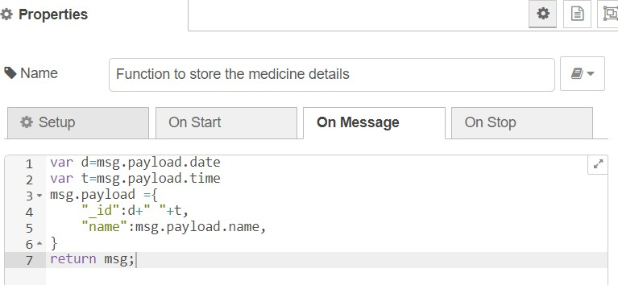

* + Another function is written to make the contents of the form empty after a delay to facilitate the entry of the other medicine details

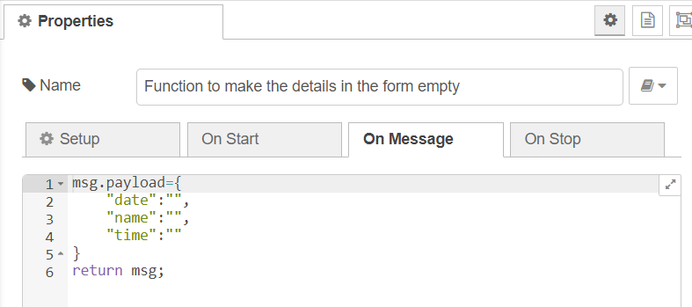

* + Node flow for the creation of the form

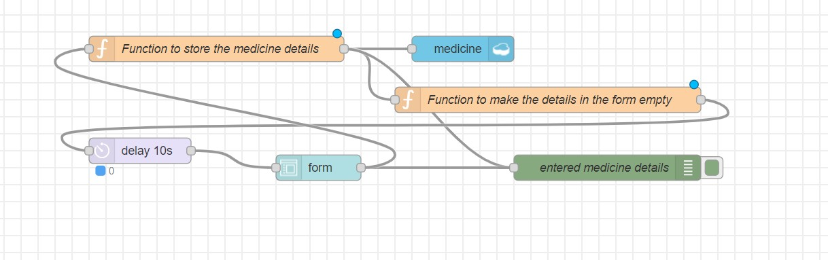

* + UI for entering the medicine details

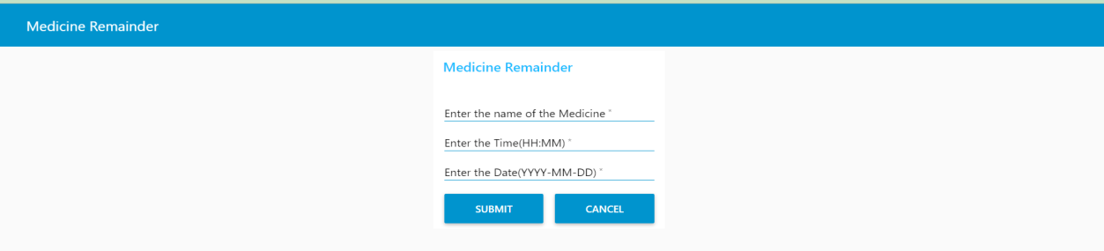

# To send the medicine name at the right time to the IoT device.

* + To accomplish this we need to write a function to compare the present time with the time entered in the form.
  + The following function will obtain the present time

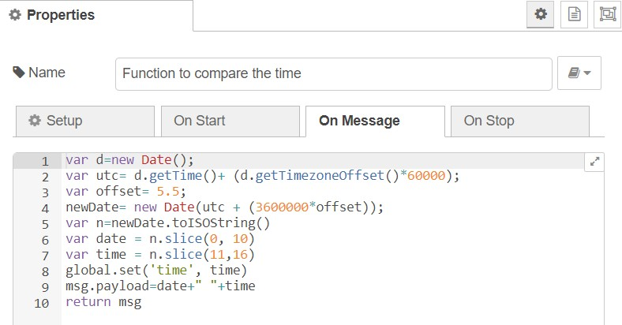

* + After obtaining the present time, cloudant in node is connected to it in order facilitate searching by _id
  + 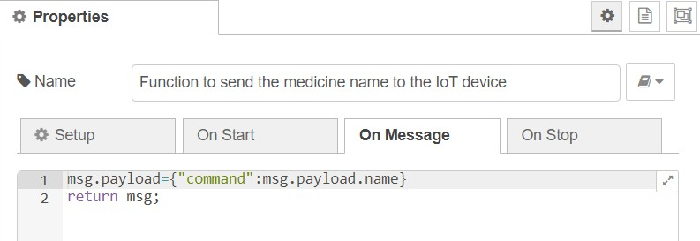If the present time and time in the database matches, then the name of the medicine will be sent to the IoT device using switch node and function following that node
  + 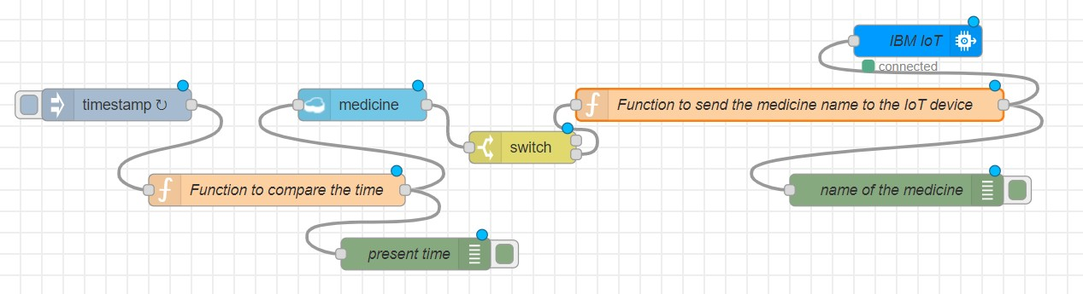Node flow for sending the name of the medicine to the IoT device

# Total node flow of the entire Web UI

1. **After deploying the following are the results**
   * The following image shows the details of the medicine entered

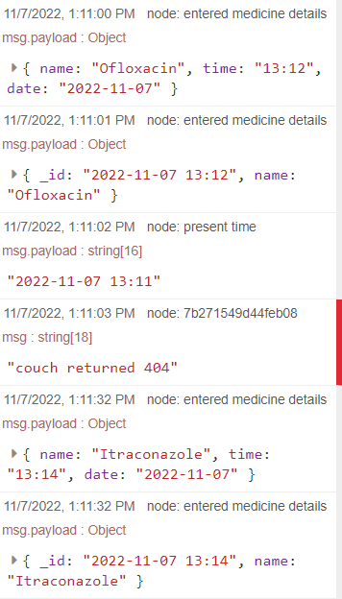

* + The following image shows the details of the medicine which is stored in the cloudant db under the medicine database

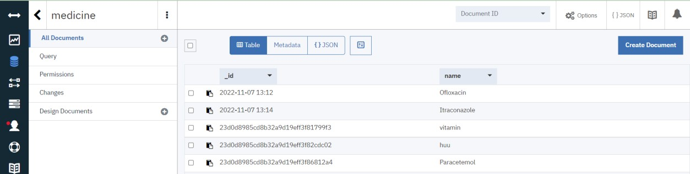

* + The following image shows the details of the medicine in the medicine database in JSON format

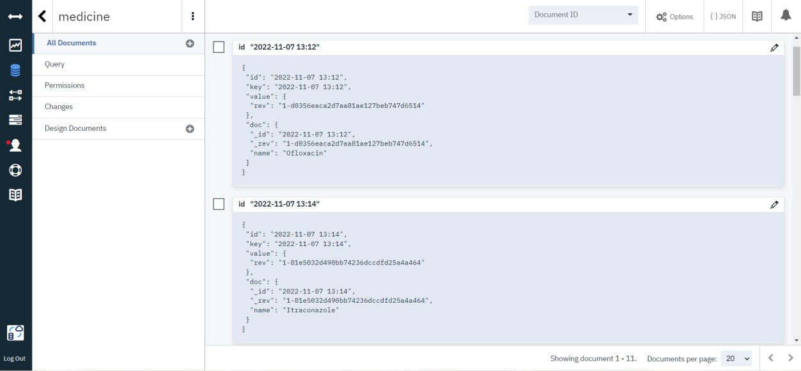

* + The following image shows the name of the medicine which is sent to the IoT device at the prescribed time
  + The medicine name Ofloxacin is sent to the IoT device as a command at the time 1:12PM

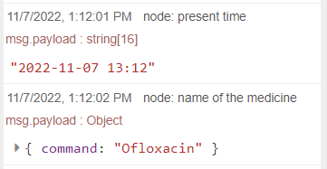

* + The medicine name Itraconazole is sent to the IoT device as a command at the time 1:14PM

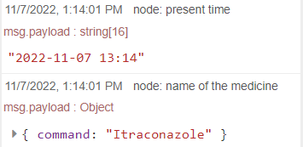

# **************************END OF REPORT********************************